INTRODUCTION
The first Most Endangered Historic Places list, released in 1996, sought to recognize historic places and structures across Maine that face the threat of deterioration and destruction. Through the years, the list shared the narratives of these places in peril, each of which has an important role in contributing to Maine’s collective history. By raising public awareness and advocating for each listing’s significance to its community, Maine Preservation hopes to prevent its loss. For its 25th edition, the Most Endangered Historic Places list calls attention to newly threatened properties while also refocusing on past listings that remain endangered. This year’s list also reflects on places that have been saved and revitalized.

CURRENTLY ENDANGERED
First Congregational Church, East Machias
The Story
The First Congregational Church structure traces its origins back to the incorporation of East Machias in the early 19th century. Originally part of the Town of Machias known as East Falls, East Machias was incorporated in 1826 and was known for its shipbuilding and lumber. John E. Seavey oversaw the construction of the First Congregational Church ten years later. Its immense scale and ornate design were a testament to the economic prosperity of the time, and its Carpenter Gothic architecture a rarity in the state.
Thomas Treadwell Stone, a Bowdoin College graduate, liberal Congregationalist, and early abolitionist, led the congregation into a revival with the construction of the new church. Prominent, founding families of East Machias, such as the Popes and Talbots, were members. The First Congregational Church also had a long-running relationship with Washington Academy, which completed its first building down the road in 1823. The school held its graduation ceremonies at the church well into the twentieth century. The First Congregational Church is joined by several adjacent community landmarks, including its c. 1850 vestry and c. 1880 parsonage to the south and cemetery to the east.

The Threat
The future of the First Congregational Church is intimately tied to the future of its congregation, which unfortunately has dwindled in size and is no longer able to steward the landmark building. Despite years of successful campaigns to fund repairs in partnership with preservation professionals, the congregation has decided it is in the best interest of the building to relinquish ownership. Just as the church’s white clapboard siding, window tracery, and quatrefoil detailing are common sites across the small towns of Maine and New England, so are its combination of challenges: a small congregation in a large historic building, with mounting costs to keep the doors open.
While a group of concerned congregants, residents and preservation advocates have thankfully formed to serve as the next stewards of the church, significant structural issues loom. One of the four main timber posts that supports the base of the steeple tower has undergone serious deterioration and is now threatening the stability of the entire structure. Once Friends of East Machias Congregational Church receives non-profit status, the Trustees of the First Congregational Church intend to transfer the deed of the property to them and pursuit of grants and donations will begin in earnest to address the pressing stabilization needs. At the same time, conversations will begin to determine what the future holds for the 185-year-old church.
How to Get Involved
The Friends of East Machias Congregational Church is in the process of formalizing as a group, but this is just the first step. If you are interested in supporting preservation of the church, please contact Doris Davis or Stephen Wells
Also, be sure to check out the important work of the Maine Steeple Fund, which supports the preservation of religious landmarks like East Machias First Congregational Church across the state.
Images
Photos Courtesy of Maine Preservation:

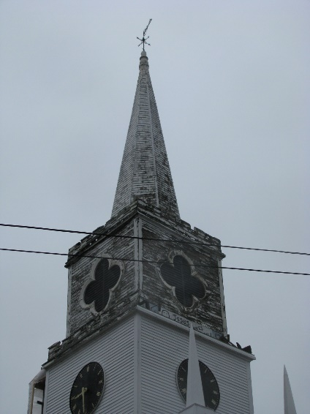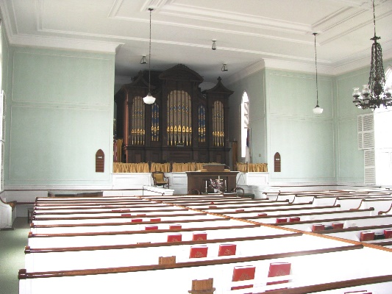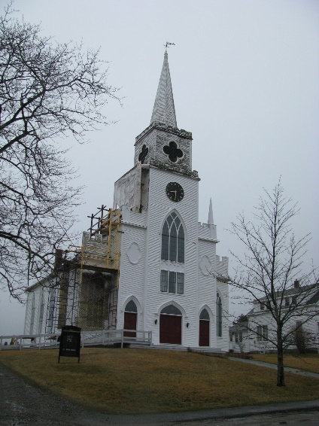
Photos Courtesy of Karen Falb of Friends of East Machias Congregational Church:
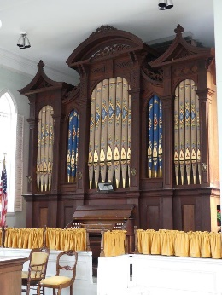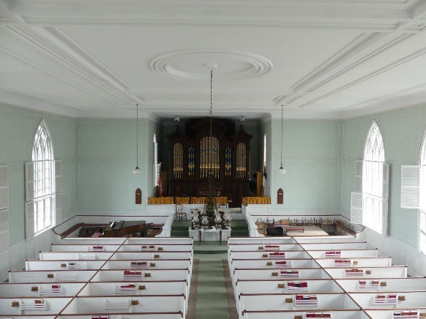

Masonic Hall, Wayne
The Story
The original Masonic Hall that stood in Wayne was part of a large industrial complex that spanned both sides of the stream below Mill Pond. On July 1, 1863, a fire destroyed the sawmill, grist mill, shovel handle factory, match factory, and the Johnson Woolen Mill. Having a building to house the fraternal order of the Masons was so important to the town that W.H. Burgess, Treasurer of the Asylum Lodge, commissioned a replacement in 1866 and construction was completed the following year.
The 1867 Masonic Hall is the final remnant of the once-thriving industrial complex of Wayne, and the last standing piece of Wayne’s industrial history. It was used by local Freemasons into the 1980s, after which time it sat mostly vacant, used only to house an annual flea market. In 2016, the building was purchased by Sustain Wayne, a local nonprofit group that wishes to see this building survive and thrive long into the future. The group plans to save this building for generations to come.
The Threat
The Hall needs immediate repairs before it faces the irreparable harm of more storms, floods, and winters. Sustain Wayne received a $50,000 grant for roof repairs from the Community Development Block Grant (CDBG) program of the U.S. Department of Housing and Urban Development, but to work on the roof, the foundation first needs to be repaired. Sustain Wayne has launched a capital campaign to raise $100,000 for the first phase of rehabilitation of the Hall. Phase 1 will address the most significant threats to the building: lifting the Hall out of the floodplain, setting it on a new foundation, and repairing the roof.
How to Get Involved
Consider making a donation to Sustain Wayne’s Phase 1 development program here, where you can also track the progress of the fundraising campaign.
More information can be found on Sustain Wayne’s website or by sending an email.
Follow along with Sustain Wayne as they work towards their fundraising goals to revitalize the Masonic Hall on Facebook and Instagram.
Images
Photos Courtesy of Maine Preservation:
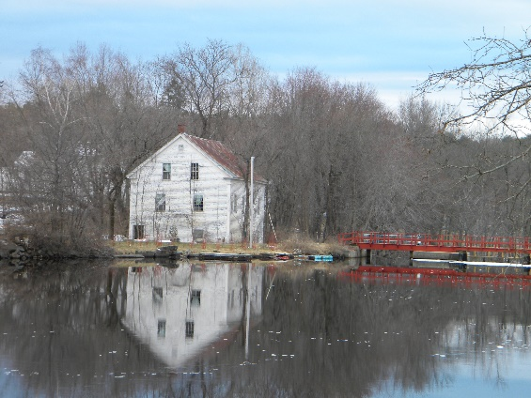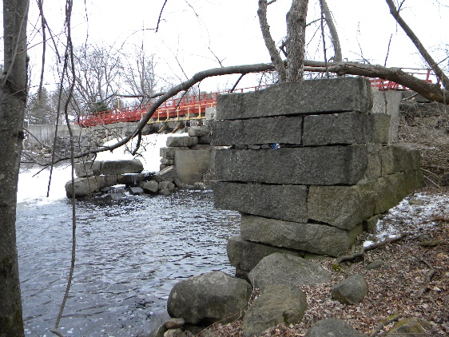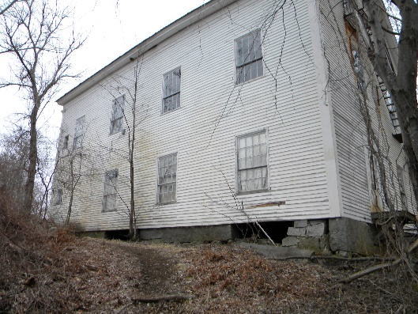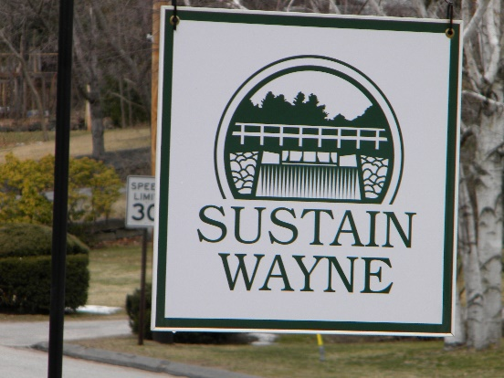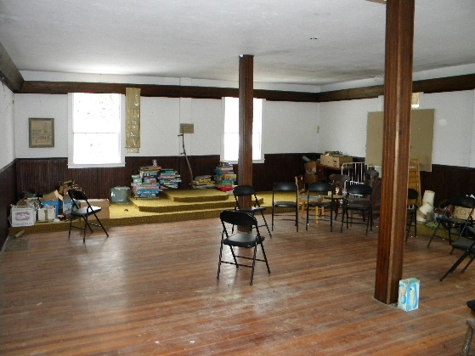
Sugarloaf Summit Lodge, Carrabassett Valley
The Story
The story of Sugarloaf Ski Mountain began in 1950 when the Sugarloaf Mountain Ski Club negotiated a 20-year lease with Great Northern Paper Company for land on the mountain. In the subsequent years, Winter’s Way was laid out (named in honor of local organizer Amos Winter), a base hut was constructed, a rope tow installed, new trails were cut, and T-Bars were added to allow skiers increased access to the mountain.

In 1964, a lift line was laid out from the top snowfields to the bottom of the mountain. The decision to buy a two-stage gondola from Cologne, Germany would transform the mountain, and it was rebranded as Sugarloaf/USA. Entering into the international ski scene, it became widely known as “The Mighty Gondola.” The midcentury modern hexagonal Summit Lodge was completed in the 1966-1967 season, just in time for Sugarloaf to host the NCAA intercollegiate skiing championship. The modern lodge marked the high point of the beloved ski resort.
Unfortunately, the gondola declined in operational capacity following an accident in 1986 until it was closed permanently in 2000. The gondola cars were sold at auction and can still be seen around the valley as a reminder of the mountain’s glory days. The lower station was replaced by the Alfond Competition Center, and various gondola parts are still scattered in the mountain woods.
The Summit Lodge was once open to Appalachian Trail backpackers as a night shelter–a dry place to escape the weather with amazing views. This continued even after the lodge was closed to skiers in the winter. Due to vandalism and mold the lodge was finally closed in 2009.
The Summit Lodge remains atop the mountain at the terminus of the phantom gondola lift. It sits vacant as skiers disembark the nearby Timberline chairlift, and swoosh past the once vibrant Summit Lodge.

The Threat
Vacant for two decades, the highly visible Summit Lodge is in need of repairs and a new lease on life. Sugarloaf 2030 envisions the next ten years on the mountain plans for the Summit Lodge are included in 2030’s “late stage,” to be completed between 2026-2030. This plan is for the transformation of the site which may include demolition of the Summit Lodge, stripping the mountain of an architecturally significant building and a piece of Sugarloaf history.
How to Get Involved
Let your voice be heard by Boyne Resorts, the owners of Sugarloaf. The demolition of the Summit Lodge will cost several hundred thousand dollars, which could be invested in rehabilitation instead.
Click here to view Sugarloaf’s 2030 plan, including public information meetings.
Images
Photos courtesy of New England Ski History:

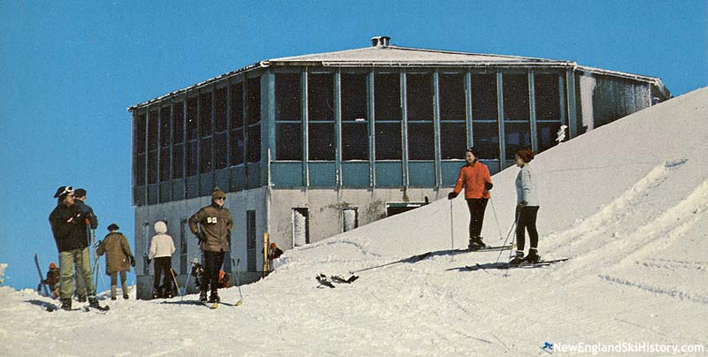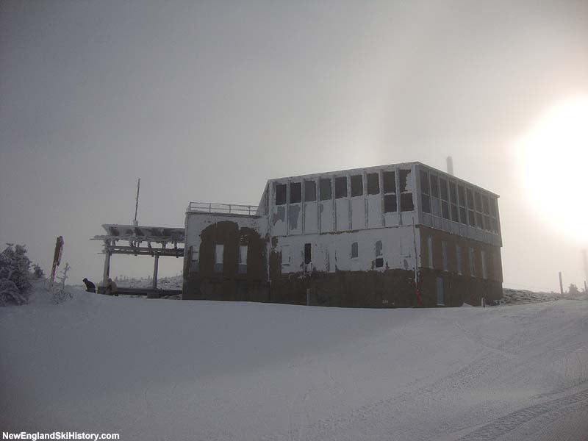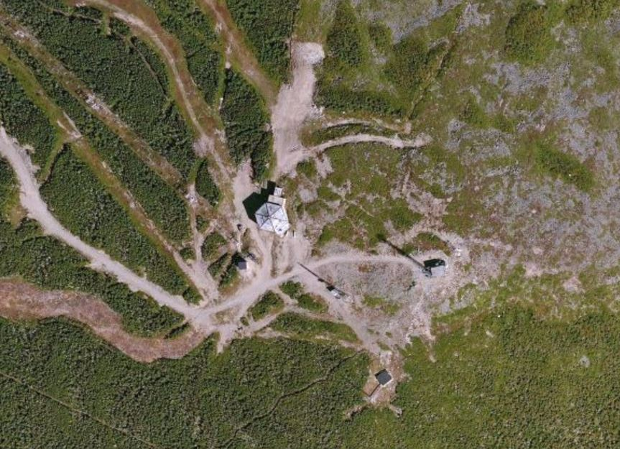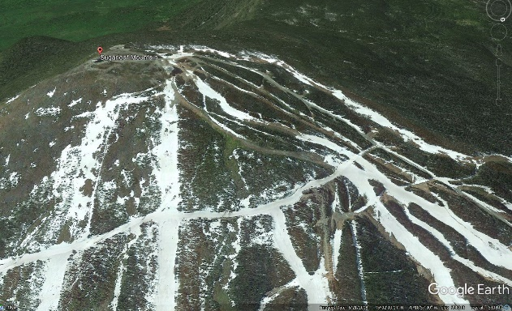
STILL ENDANGERED
McCurdy’s Smokehouse, Lubec
The Story
McCurdy’s Smokehouse appeared on our first Most Endangered Historic Places list in 1996. As with any historic site, it does not only take one singular effort to ensure long-term preservation and the McCurdy Smokehouse is no exception. Lubec Landmarks, Inc has done an amazing job in keeping what was the last operating herring smokehouse in the United States alive. In the 2000s, the two buildings closest to shore were restored: The Mulholland Market Building and the Skinning/Packing Shed. The Mulholland Market Building is used as an art gallery for local artists, and the Skinning/Packing Shed houses the Historic McCurdy Smokehouse Museum. These buildings are open to the public during the summer months and run by volunteers.
However, the Brining Shed, the furthest building out in the Narrows, was lost in a 2018 Nor’easter. More recently, the complex was further imperiled by the highest tide to hit Downeast Maine in 100 years on April 10, 2020 when Lubec experienced a tide that was roughly five feet higher than the normal yearly King’s tides.
The Threat
The threats that McCurdy’s faces today are similar to those it confronted in 1996, and likely only going to worsen with the impacts of climate change. The Sawdust Shed and the South Smokehouse are sinking into the gravel beach, and the tides periodically rise above floor level. Action is needed to raise these buildings on a new taller wooden piling foundation, with a new wharf to connect the remaining four buildings.
How to Get Involved
The McCurdy Smokehouse has received an outpouring of support from the local community. However, Lubec Landmarks, Inc needs to raise roughly $500,000 to place these two buildings on taller pilings.
You can support McCurdy’s Smokehouse by visiting the museum, purchasing McCurdy’s Smokehouse merchandise in their online store, and by donating directly to their preservation efforts.
Images
Photos courtesy of Maine Preservation:

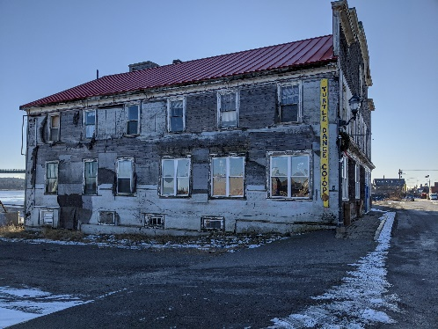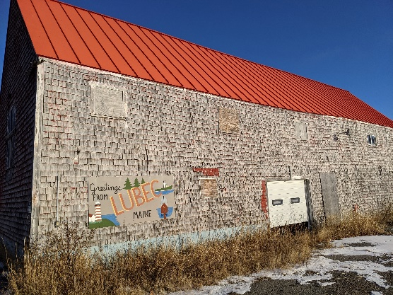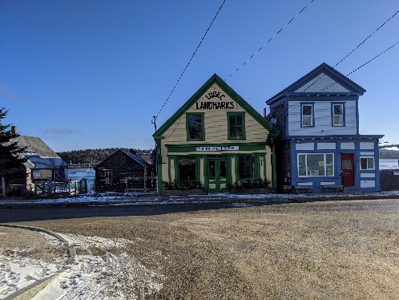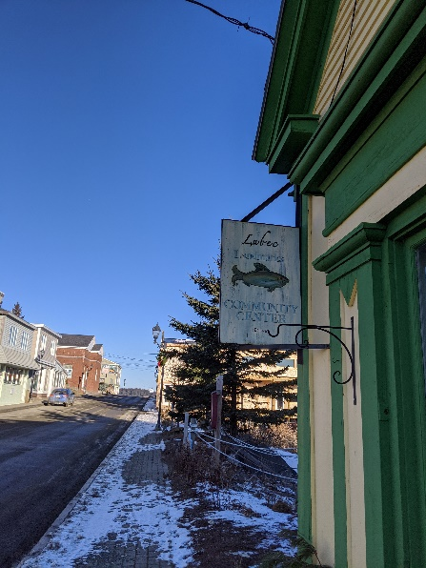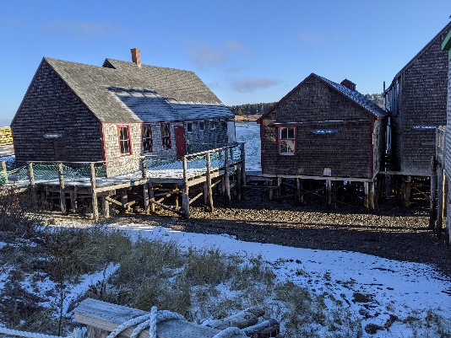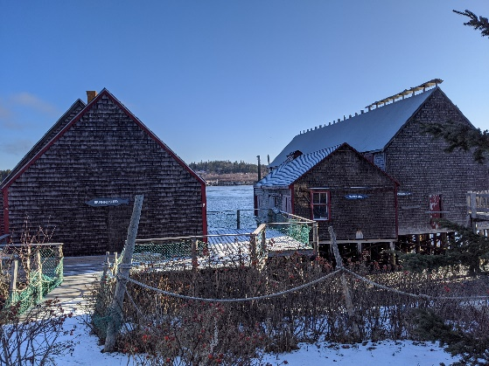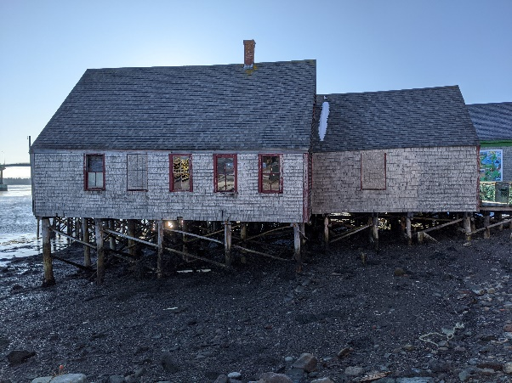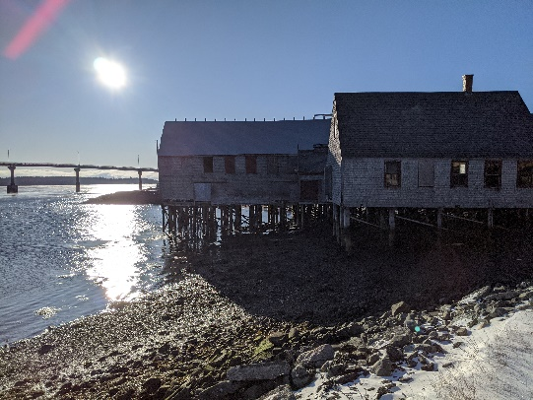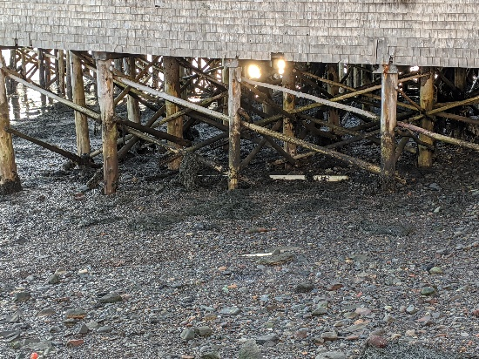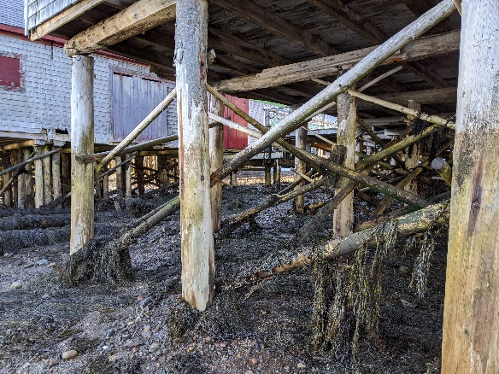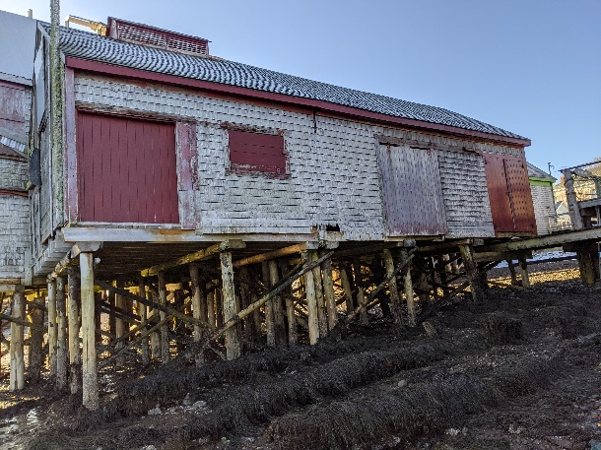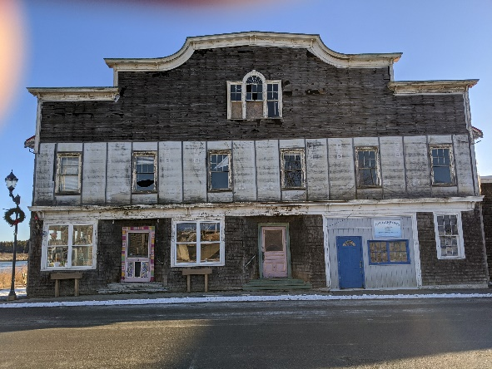

Frank J. Wood Bridge, Topsham/Brunswick
The Story
Constructed in 1932, the Frank J. Wood Bridge is one of the largest metal truss bridges built during the Great Depression in Maine. The 815-foot long bridge touts a 310 foot central span, that not only served as a connector for automobiles and pedestrians, but also for an interurban rail line that connected the Brunswick area with Lewiston. The bridge’s trio of metal spans became an iconic symbol along the Androscoggin River, between Brunswick and Topsham, featured in advertisements, on phone books, and serving as a subject of photographers for decades.
The Threat
Many of Maine’s bridges are in alarmingly bad shape, including the Frank J. Wood Bridge. The Society of Civil Engineers found that the floor system is failing, crossbeams are deteriorated, and the sidewalk supports are corroded. In 2017, the Maine Department of Transportation proposed a plan to completely replace the bridge, asserting that rehabilitation of the historic structure would cost more than building new. Construction of a new bridge also raised concerns about potentially obstructing the remaining view of the natural waterfalls from the road, covering a significant Native American and early European historic site, and having a potentially harmful impact on three endangered species of fish which spawn at the foot of the dam.
The Friends of the Frank J. Woods Bridge has formed in an attempt to save the bridge. In the fall of 2020, this group, along with National Trust for Historic Preservation and The Historic Bridge Foundation, filed a lawsuit against the Maine DOT and the Federal Highway Administration with the goal of enforcing preservation rather than replacement.

How to Get Involved
Click here to learn more about the history of the Frank J. Wood bridge and the significant role it has played in the area for nearly a century.
Watch the oral arguments for the appeal to preserve the bridge held in the First District Court in Boston on September 13, 2021 which can be accessed here.
Contact the Friends of the Frank J. Wood Bridge via email to offer your support and follow them on Facebook for the latest updates.
Images
Photos courtesy of Maine Preservation:
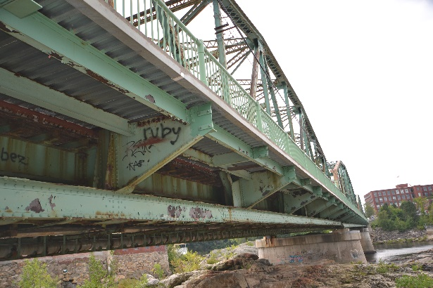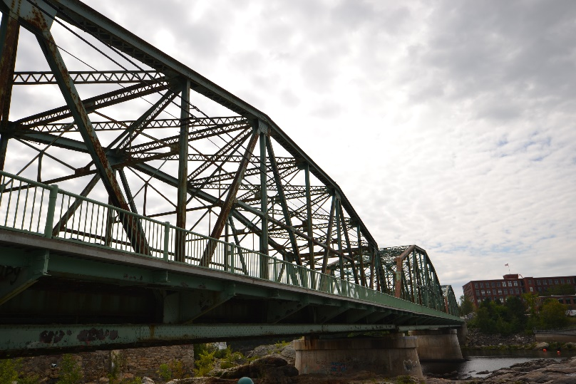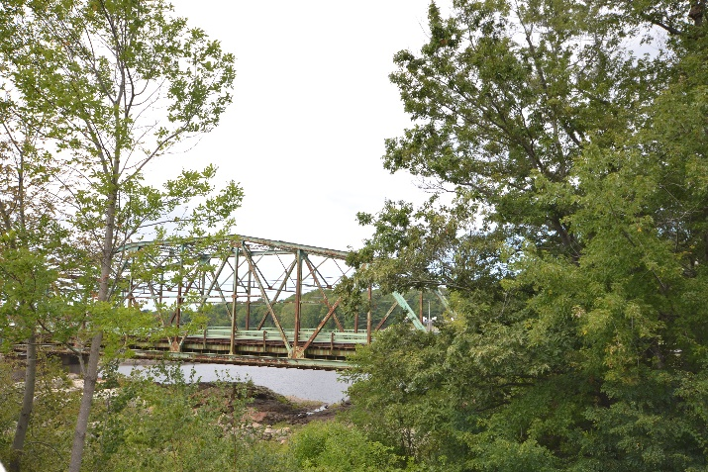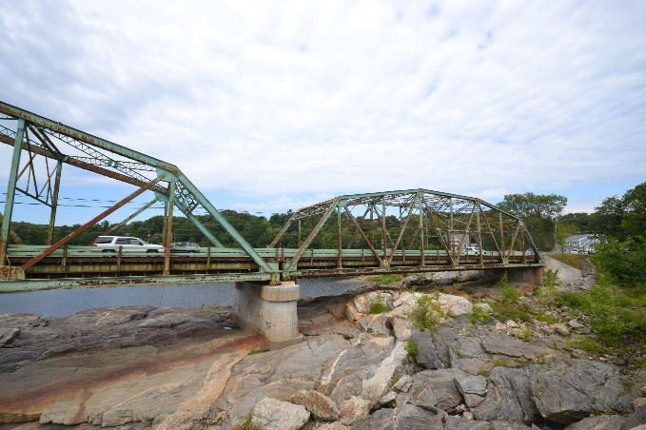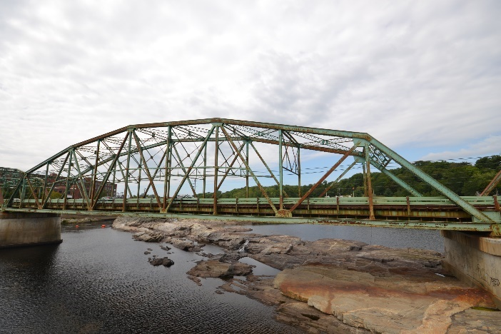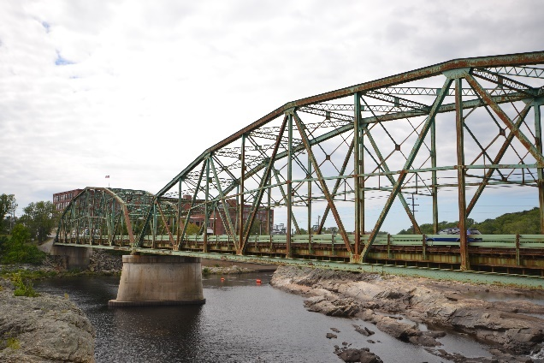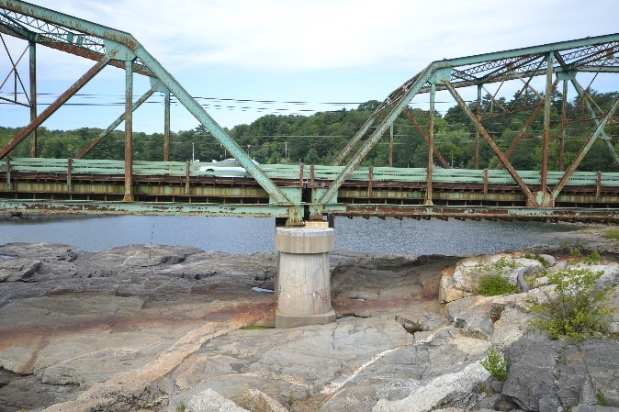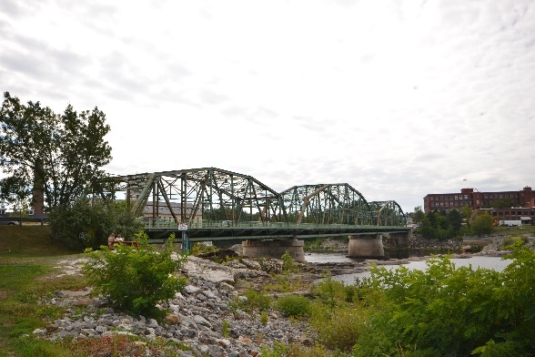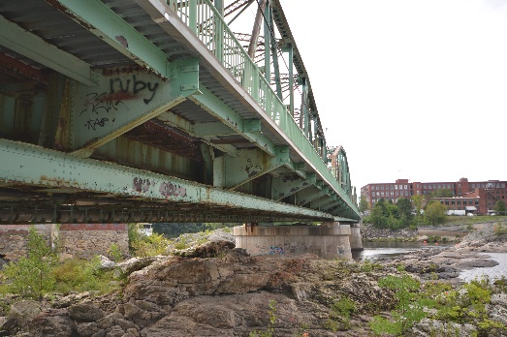
Kennebec Arsenal, Augusta
The Story
The Kennebec Arsenal is situated on a 41-acre parcel of land on the east side of the Kennebec River in Augusta. The compound consists of eight buildings constructed between 1829-1839. Built to fortify open ground in response to the War of 1812, the Kennebec Arsenal also functioned as a munitions depot during the Northeast Boundary Controversy with Great Britain. Today, the Arsenal serves as the best example of an early 19th-century military depot and remains a significant historic landmark for its role in the Northeast Boundary Controversy.
The Threat
In 2007, the complex was purchased by developer Tom Niemann of Durham, North Carolina, who replaced several roofs that were leaking. Since then, buildings have been largely untouched and continue to deteriorate. The Concerned Citizens for Augusta’s Historic Preservation of the Kennebec Arsenal have joined together to take action and await enforcement of historic preservation covenants and property maintenance ordinances by the city.
How to Get Involved
Learn more about the Concerned Citizens for Augusta’s Historic Preservation of the Kennebec Arsenal by watching recent coverage in the news and following along on Facebook. For further information on what the city is doing, please contact Development Service at Augusta City Hall at 207-626-2365. It is also important to contact your local Senators and Legislators across the state to make them aware of this dire situation.

Images
Photos courtesy of Maine Preservation:
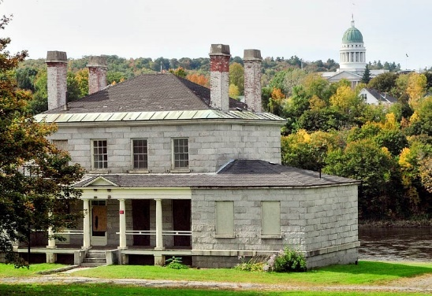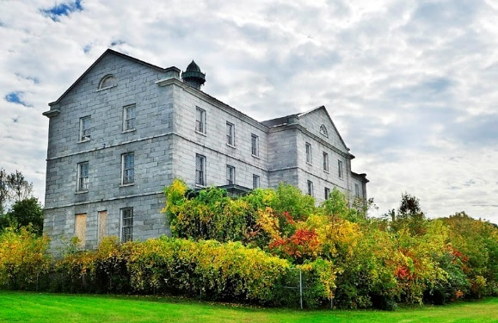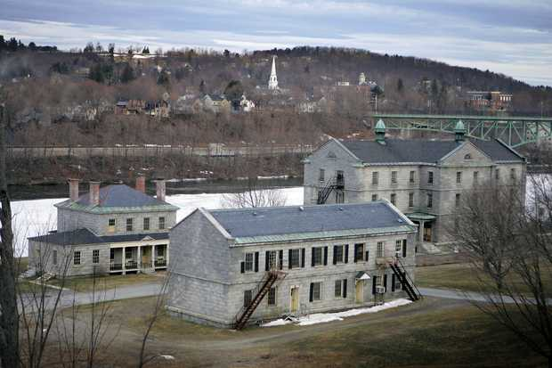

SUCCESS STORIES
Maine Downtowns, Statewide
In Maine Preservation’s first Most Endangered Historic Places list, it recognized Maine Downtowns as being threatened by dwindling populations, shopping mall development, and sprawl. Maine’s 10 National Main Street programs and 13 Maine Downtown Affiliate programs along with the Maine Downtown Center have dedicated time and energy towards revitalizing many of Maine’s downtowns. While many towns still face the threat of climate change and outdated industrial systems, significant improvements have been made to stabilize these economies and increased focus on local commerce.
Images
Houlton Downtown photos courtesy of Christopher A. Mills:
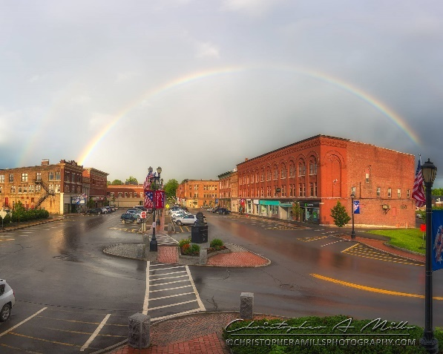
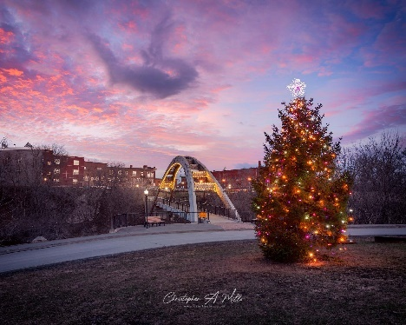

Downtown Gardiner photos courtesy of Gardiner Main Street:
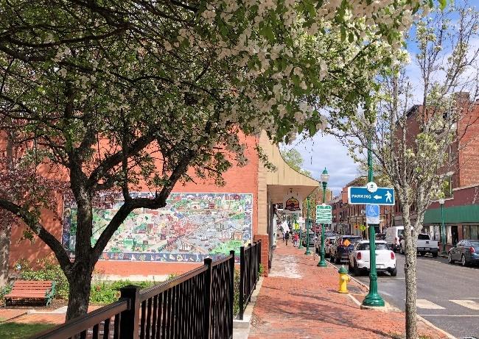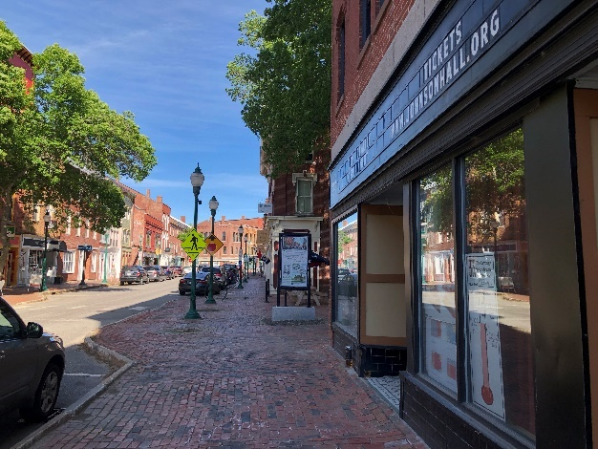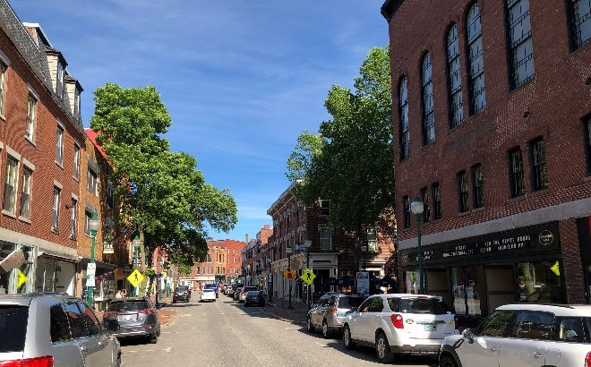
Downtown Skowhegan photos courtesy of MXH Marketing:
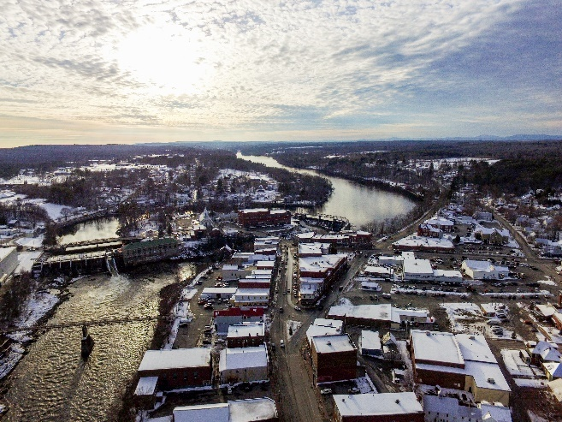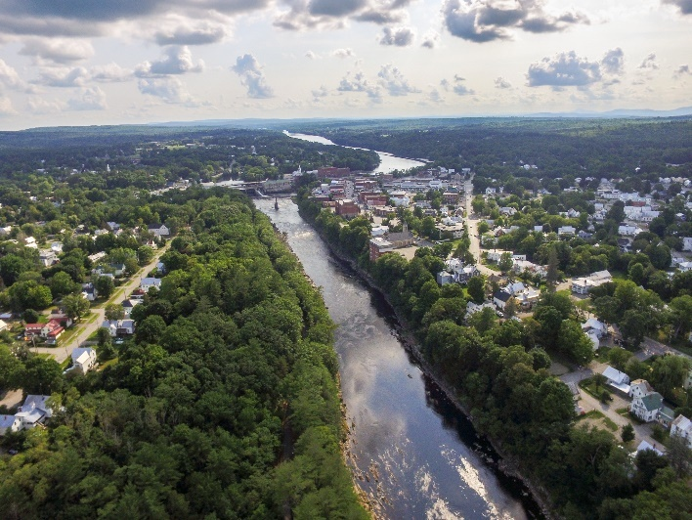

Saco Mill No. 4, Saco
Saco Mill No. 4 was the last mill in the Saco area to face restoration after nearly 30 years of neglect, and was placed on the Most Endangered Historic Places list in 2002. Since then, redevelopment efforts have succeeded in revitalizing the building and transforming the mill into 150 apartments and 30,000 square feet of commercial space. The project, which relied on federal and state historic preservation tax credits, was led by real estate developer Eric J. Chinburg and the City of Saco, with financing made possible by Maine-based Camden National Bank and Coastal Enterprises, Inc. This is a wonderful example of an adaptive reuse project that helps to preserve the distinct character of the area and serves as a model for other mill rehabilitation projects across Maine.
Images
Photos courtesy of Maine Preservation:
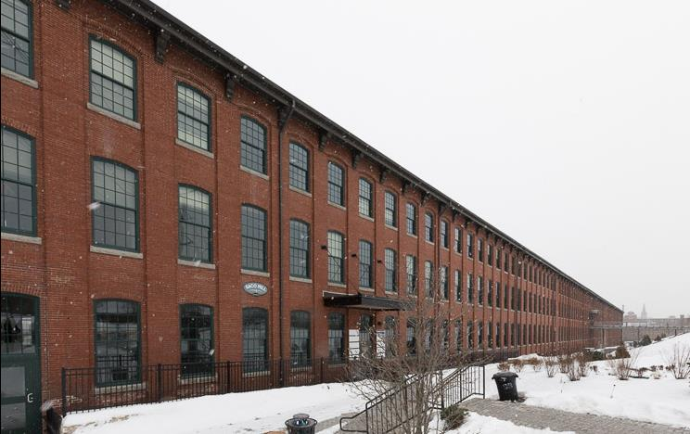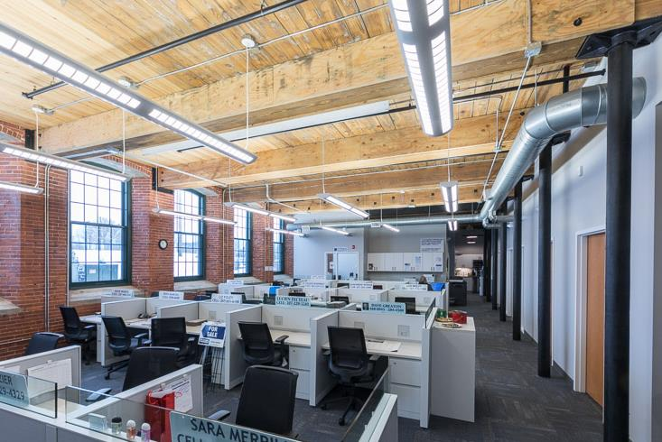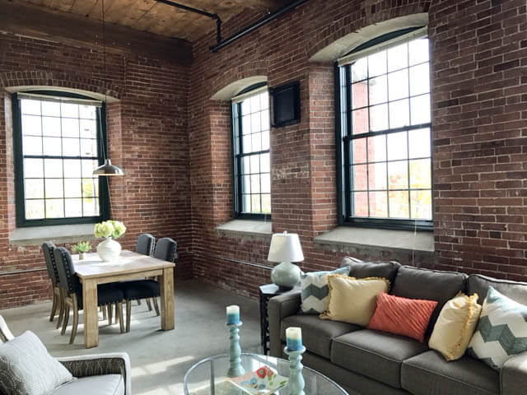

Wood Island Life Saving Station, Kittery Point
Though the work continues at the Wood Island Life Saving Station, it is certainly a success story. Having deteriorated since the mid-1970s, the Town of Kittery considered demolishing the building in 2009 and a group of concerned citizens quickly mobilized and created Wood Island Life Saving Station Association (WILSSA). In 2012, the Station was listed as one of Maine Preservation’s Most Endangered Historic Places. Since then, WILSSA has raised nearly $4 million for the preservation of the station which will act as a marine museum. In 2015, the group submitted an eligibility assessment to the National Register of Historic Places which contains a detailed history and many photos of the Station. Follow the progress of this amazing story on the Wood Island Live Saving Station Association’s website and watch videos of the restoration process and a live stream of the island on the Wood Island Youtube channel.
Images
Photos courtesy of Wood Island Life Saving Station: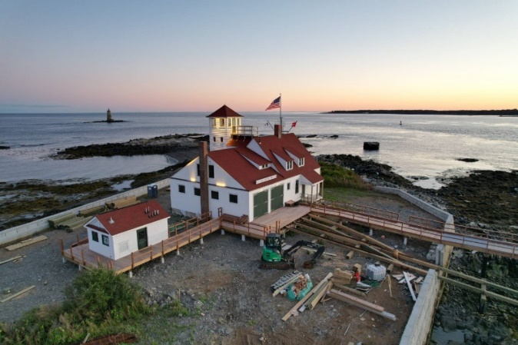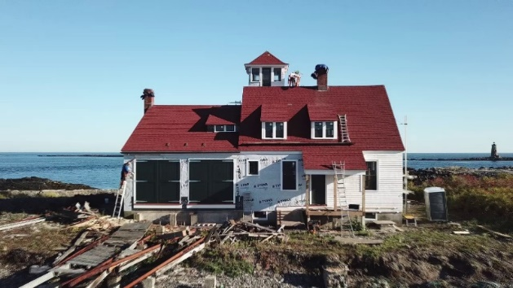

Photos courtesy of Maine Preservation:
